4-H Online Staff Guide for Creating SPIN Clubs, Adding Members, Viewing Participants, and Reporting to PEARS
4-H professionals can request to have a new SPIN club created, edited, or archived anytime throughout the program year by completing the Club Management Survey.

Important notes prior to having a SPIN club created in 4-H Online:
- If your SPIN club is being organized by multiple staff from different counties and/or advertised to youth in multiple counties, one county 4-H Online account will house the SPIN club.

Example: Eaton, Schoolcraft, and Livingston Counties are collaborating on a SPIN Club. Staff determine that Schoolcraft County will manage registrations for the club in 4-H Online. A new SPIN Club request needs to be completed by the Schoolcraft 4-H professional by completing the New Club Survey at:

- Typically SPIN Clubs are not statewide clubs.

- All SPIN Clubs are titled with the words SPIN Club first and then name of club. (Example: SPIN Club Sanilac Cloverbud Crafts)

- When a Request to Create a New SPIN Club is submitted, you must indicate what project areas are offered. Those project areas will be linked to the club at time of setup.

- If the SPIN Club needs a maximum number of enrollments set, you must indicate that number in the Create Club Survey.

- You can request to turn “allow registration OFF” for the SPIN Club after your enrollment period ends and/or the program has ended. To request the SPIN Club’s registration be deactivated, County 4-H Staff must submit a Request to Edit the Spin Club by submitting a Club Survey.

- Turning the “allow registration” setting to NO does not delete the club. It only turns the ability for members to register in the club off.

- If you need the SPIN Club archived, please submit a Request to Archive the SPIN Club. A club with any current-year enrollments will not be able to be archived until the year rolls over.

- All clubs, including SPIN Clubs, must have the Civil Rights Statement. This is a required upload when submitting a Request to Create a NEW SPIN Club.

- 4-H Online functions best when your computer’s web browser is maximized.

Club Management Survey link: https://msu.co1.qualtrics.com/jfe/form/SV_6M4qUumkwmLCP5Q

For questions related to Chartered Clubs, please email: msue.4hfinancial@campusad.msu.edu

For all other 4-H Online questions, please email: kruege61@msu.edu

SPIN Club files/ forms link: https://drive.google.com/drive/u/0/folders/1C87v-PAzP7ENk2jYcb2lKtvWSsoy0ulB

Club Settings and Projects

Club Details: Michigan is now utilizing the Institution Hierarchy restriction feature. This restricts changes to the Club Details section being done by staff.

Club Details will be requested fields when completing the Club Management Survey.

Club Settings are also restricted to the Institution Hierarchy. A Club Management Survey can be completed at any time to make changes to the Maximum Enrollments, Allow Members to Register, and Allow Members to See Their Registration.

The areas of club management counties can edit are Contact, Contact Address, Meeting Details, Meeting Address, and Projects by using the EDIT tab.

**NOTE: When the registration period or the SPIN club is over, you can submit a Request to Edit Club survey to turn the “Allow Members to Register” to OFF. This action will remove the SPIN Club from the list of clubs youth see when enrolling in 4-H Online.

Viewing Enrolled Members
There are two areas where counties can view the members enrolled in a SPIN Club (or any club).
Both methods will report all members of the club, not just primary club members.
To download a SPIN club roster:  - Click on Clubs in the left navigation menu.  - Locate the SPIN club and open it.  - Click on the Download Roster button in the upper right corner.  - A list of members enrolled in the club will export to an Excel file.  Note: The list will include all members enrolled in the club from all counties as well as enrollment status. | 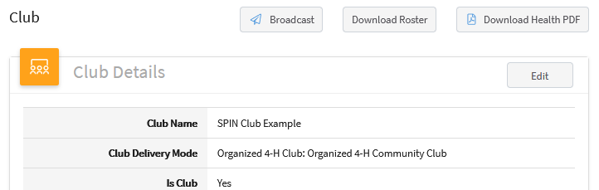  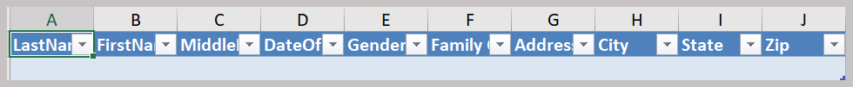
View and access member profiles:  - Click on Participation in the left navigation menu.  - Type the name of the SPIN club in the Clubs box.  - Click Search.  Managers can access member enrollment records by clicking on a member name in the search results. | 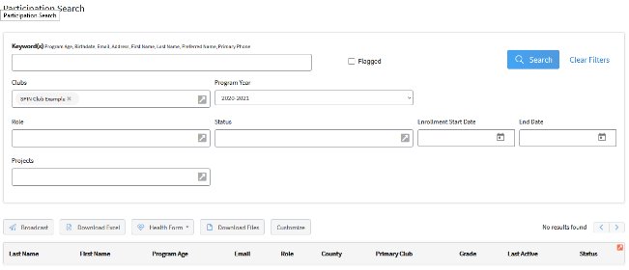  A grid with participant data will appear below the column headings
NOTE: If the member’s primary enrollment county is not the same county hosting the club, access to the member record will be read-only.
The columns that are displayed can be customized using the Customize button. The list can be downloaded to an Excel file by clicking on the Download Excel button.

Add a SPIN Club to Approved Members
There are two ways a SPIN club can be added to a member’s profile after the enrollment has been approved:
- County Managers (of the youth’s primary county) can add additional clubs to an approved enrollment through the Enrollments in the navigation pane. County managers can only add clubs for a member if the member’s enrollment has been approved in the county the manager has access to in 4-H Online. See the instructions below.
If a member’s enrollment has not been approved, the member will need to login to their profile and add the SPIN club to their enrollment. This will create a Club Request the county manager will need to approve.
- Members can login to their profile and submit a Request to Add Club using the instructions in the 4-H Online Family Guide.
- The primary club’s county manager receives the request (but will not receive an email notification) and must approve the request before the club is added to the member’s enrollment. See instructions on the following page.
County Manager Adding Club to Approved Enrollments:  - Click Enrollment in the left navigation pane.  - Click the Approved tab at the top.  - Search for the approved member.  - Click on the member in the search results. | 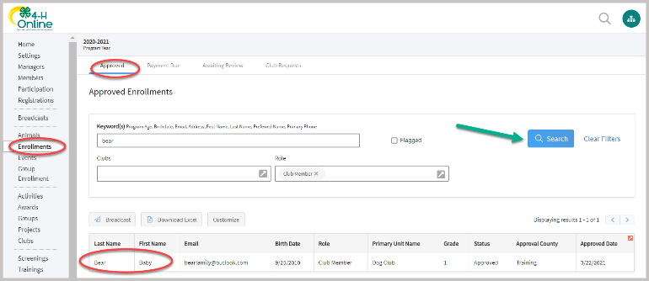
- Click on the Edit button in the Clubs section. | 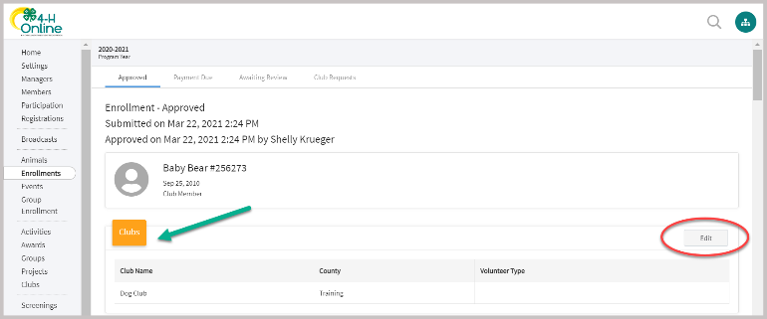
- Click on Select Units.  - Select the club’s county in the drop-down list.  - Scroll through the club list.  - Click Add on the club to be added  - Click Save. | 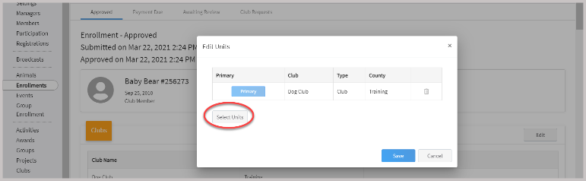
IMPORTANT NOTE:  - You MUST scroll down to Projects and repeat the above steps to add the project area/s for the SPIN Club. Be sure to filter for the SPIN club that was just added by using the club drop-down list. | 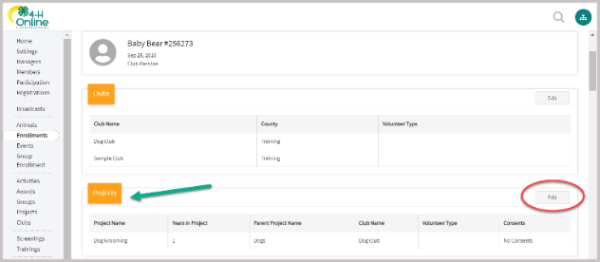
Preparing to accept member club requests:  A county’s primary 4-H Online administrator must change the county’s 4-H Online settings to allow families to edit clubs and projects on approved enrollments.  - Click on Settings in the left navigation pane.  - Scroll down to the Member section and click Edit.  - Check box to activate Member Edit Projects.  - Check box to activate Member Edit Club.  - Click Save. | 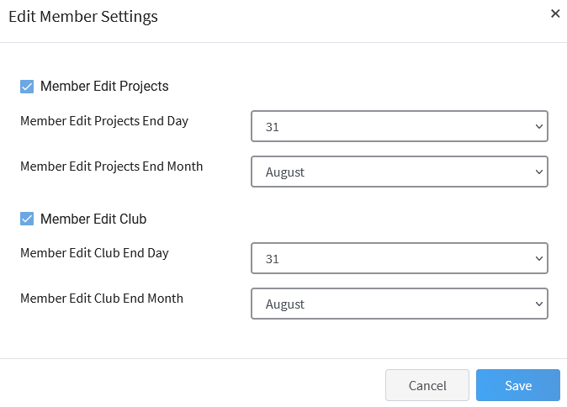
Approving a member’s club request:  - Click on Enrollments in the left navigation pane.  - Click on the Club Requests tab at top.  - Click on a member to review the club request.  - Enter a Manager Comment.  - Click Approve if appropriate. | 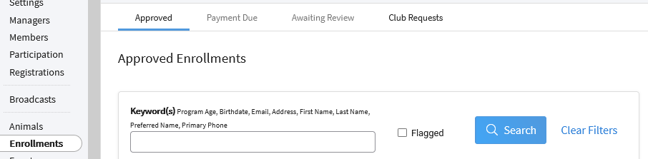  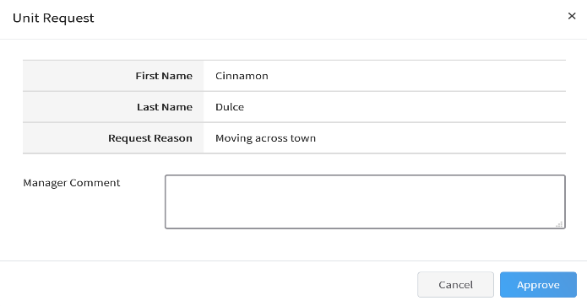
IMPORTANT NOTE: County Managers must add projects!
- You MUST add the project area/s that are associated with the newly approved club.
- Go to the member’s profile.
- Scroll down to Projects in the left navigation pane.
- Click Edit, click Select Projects.
- Filter for the club that was just added.
- Click Select next to the appropriate project area/s for the SPIN club.
- Click Add.
- Close Edit Projects box.

Reporting A Collaborative SPIN Club in PEARS
4-H Online is the data management system used to record youth enrollments and participation in Michigan State University Extension programs. The number of youth enrollments and adult volunteers housed within a county’s 4-H Online account are not indicative of the number of youth participants/adult volunteers residing in that county nor of the county staff member’s individual work. Effort and reach reporting for individual staff members is housed in PEARS.
When clubs/collaborative programs with member enrollments are delivered by staff members (as opposed to volunteers), data must be pulled from 4-H Online and entered in a PEARS Program Activity. This guide only walks through the applicable portion of PEARS as there are other complete guides on entering Program Activities in PEARS.
NOTE: Data should be pulled from 4-H Online and entered in PEARS by the staff person who is managing the club’s registration in 4-H Online. Example: If Eaton, Schoolcraft and Livingston Counties are collaborating on a SPIN Club and the club is located in Schoolcraft County’s 4-H Online account, Schoolcraft staff would pull the 4-H Online report and create the PEARS activity, adding Eaton and Livingston staff as collaborators in PEARS.
Pulling data from 4-H Online:  - In the left navigation menu, select Custom Reports.  - In the Reports Columns section, expand your county folder by clicking the > to expand the folder.  - Click on the Demographics for PEARS Reporting title.  - In the gray box that appears, click Copy Report. | 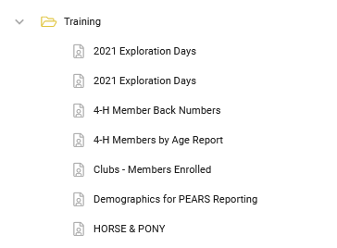  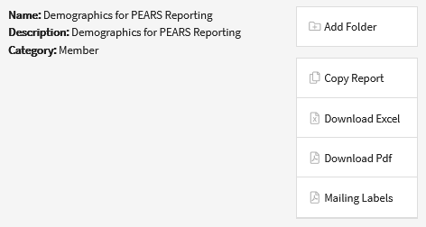
The report will now appear in your list of reports and may be edited. | 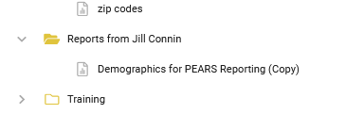
- Click on the report title.  - In the gray box that appears, click on Edit Report. | 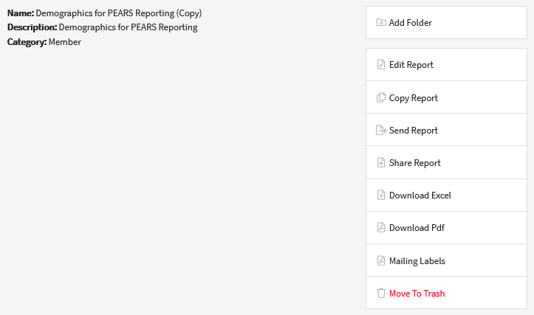
- In the report settings, locate Standard Filters, click Edit.
- Set options as necessary if you need specific member/volunteer sorting.
- Locate SPIN club in the Units menu and select it.
- Click Save.

4-H Online uses “units” and “clubs” interchangeably.
- At the bottom of the report creation screen, Refresh the preview to be sure data looks the way you expect.  - At the top of the report page, click Download Excel. | 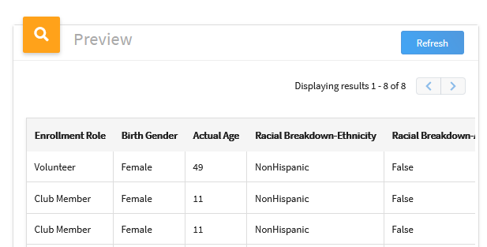
This will create a spreadsheet where you can use the Columns Filter tool to sort and calculate data to report in PEARS (demographics). Use Excel online tutorials to learn how to do this if desired.
Reporting into PEARS:  This covers the related portions of PEARS Program Activity data and is not comprehensive of all areas of Program Activity reporting.  - In the Youth Programming section of PEARS, all youth data pulled out of 4-H Online is treated as 4-H Youth data. If there were youth registrations collected that were not collected in 4-H Online enrollments, that data is (generally) treated as Non 4-H Youth.  - PEARS is easy if all registrations were in 4-H Online. Simply complete the top portion and enter the breakdown of genders, being mindful of which column is being used.  - The rest of this page can be left alone if all participants are recorded in 4-H Online. | 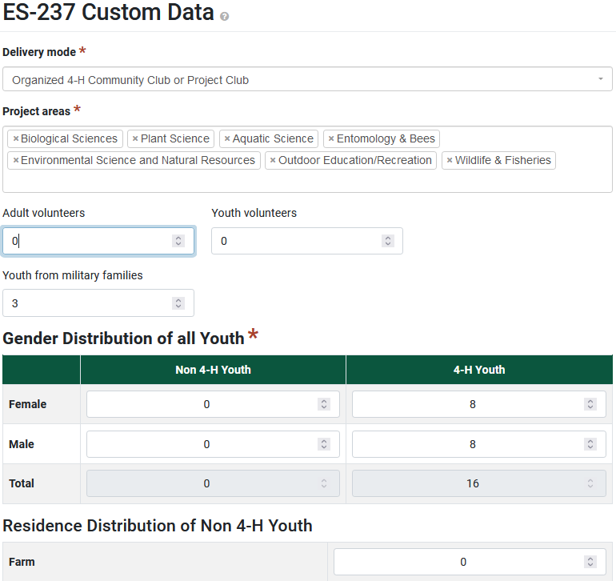
- In the Program Activity Demographics section, use the Auto-Calculate button to bring over all the data from the Youth Programming page.  - Then, update the Total participants to include all youth and adults.  - Change the Method used to Actual Count.  - Change the Source to Survey of target audience.  - Then use your Excel spreadsheet to complete/update the rest of this section, using data for all youth and adult participants/volunteers (not including MSU Extension staff).  - Click Save. | 